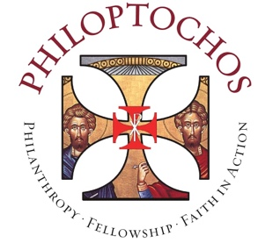
Operation Classroom 2025
A National Philoptochos Initiative
July 2025 – December 2025
Complete and save the form below and email to your Metropolis
Liaison no later than January 16, 2026.

Date
Chapter Name and Number
Parish Name
Parish Address
Metropolis
Contact Name
Contact Email
Number of students served
Total funds spent
Brief description of project

